**DAILY REPORT**

**Student Name :SINDHU.N**

**Class and Sec : VI B**

**USN :4AL17CS094**

**DATE:14-08-2020**

|  |  |  |  |  |
| --- | --- | --- | --- | --- |
| **Online Test Details** | | | | |
| **Subject** | ------ | | | |
| **Semester** | VI -B | | **Duration** | ----------- |
| **% of marks** | | ---- | | |

|  |  |  |  |
| --- | --- | --- | --- |
| **Certification Course Details** | | | |
| **Course** | Cyber Security | | |
| **Certificate Provider** | Great Learning | **Duration** | 5.5hours |

**Snapshots of the daily class acitivities .**

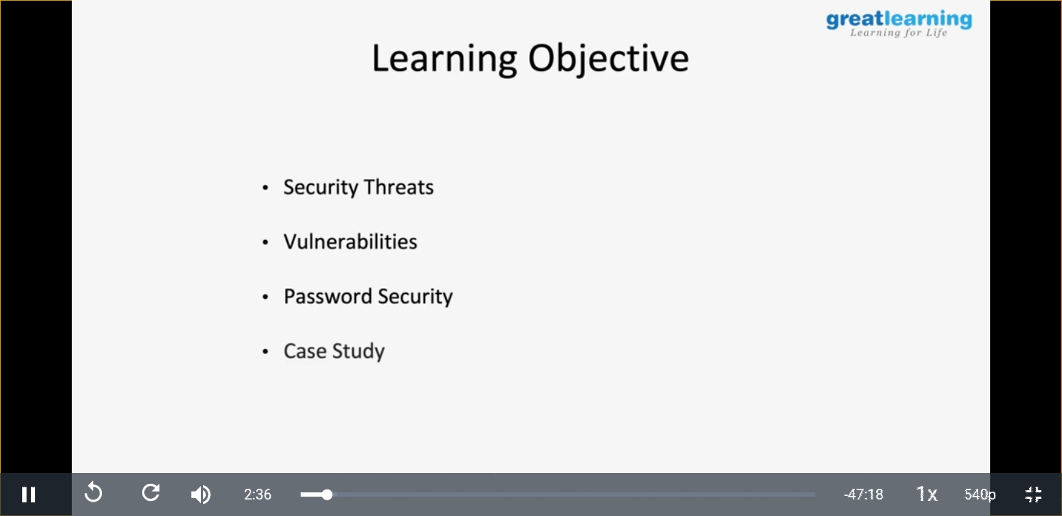

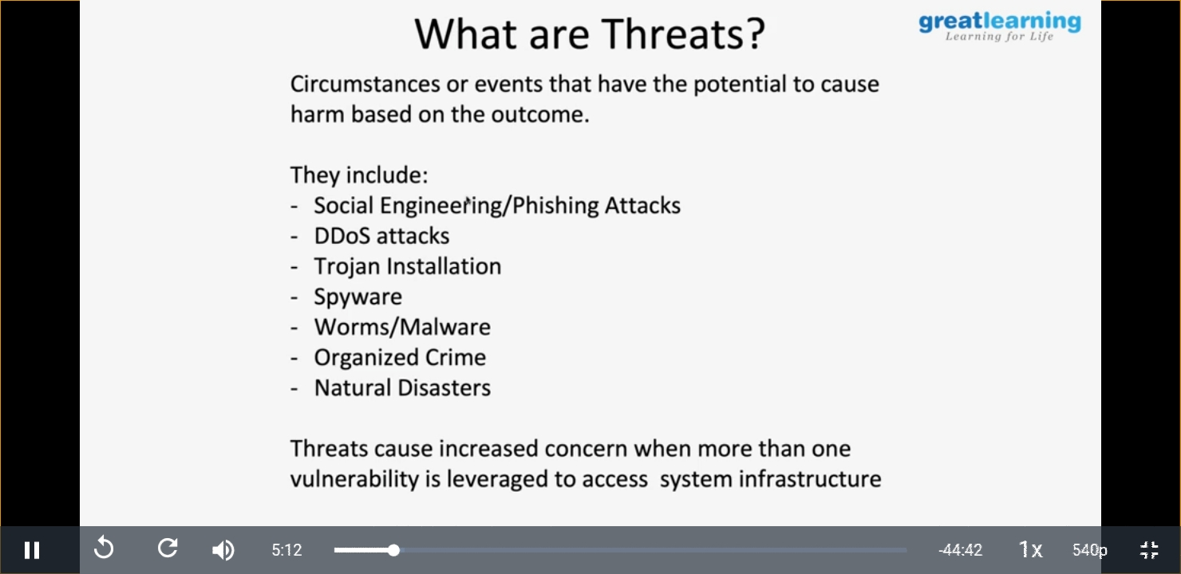

|  |  |
| --- | --- |
| **Coding Challenges** | |
| **Problem Statement:**  1.**Python program to check if a string contains all unique characters.** | |
| **Status:** Executed | |
| **Uploaded the report both in Github & Slack** | Yes |

**Snapshots of your response to challenge.**

1. ****Python program to check if a string contains all unique characters.****

def isUniqueChars(st):

if len(st) > 256:

return False

char_set = [False] * 128

for i in range(0, len(st)):

val = ord(st[i])

if char_set[val]:

return False

char_set[val] = True

return True

st = "abcd"

print(isUniqueChars(st))

**OUTPUT**

